Project Design Phase-II
Technology Stack (Architecture & Stack)

Date | 15-7-2026
Team ID
Project Name | Book Store
Maximum Marks

Technical Architecture:
The Deliverable shall include the architectural diagram as below and the information as per the table1 & table 2
Example: Online Book Store System using MERN Stack (React, Node.js, Express.js, MongoDB Atlas)
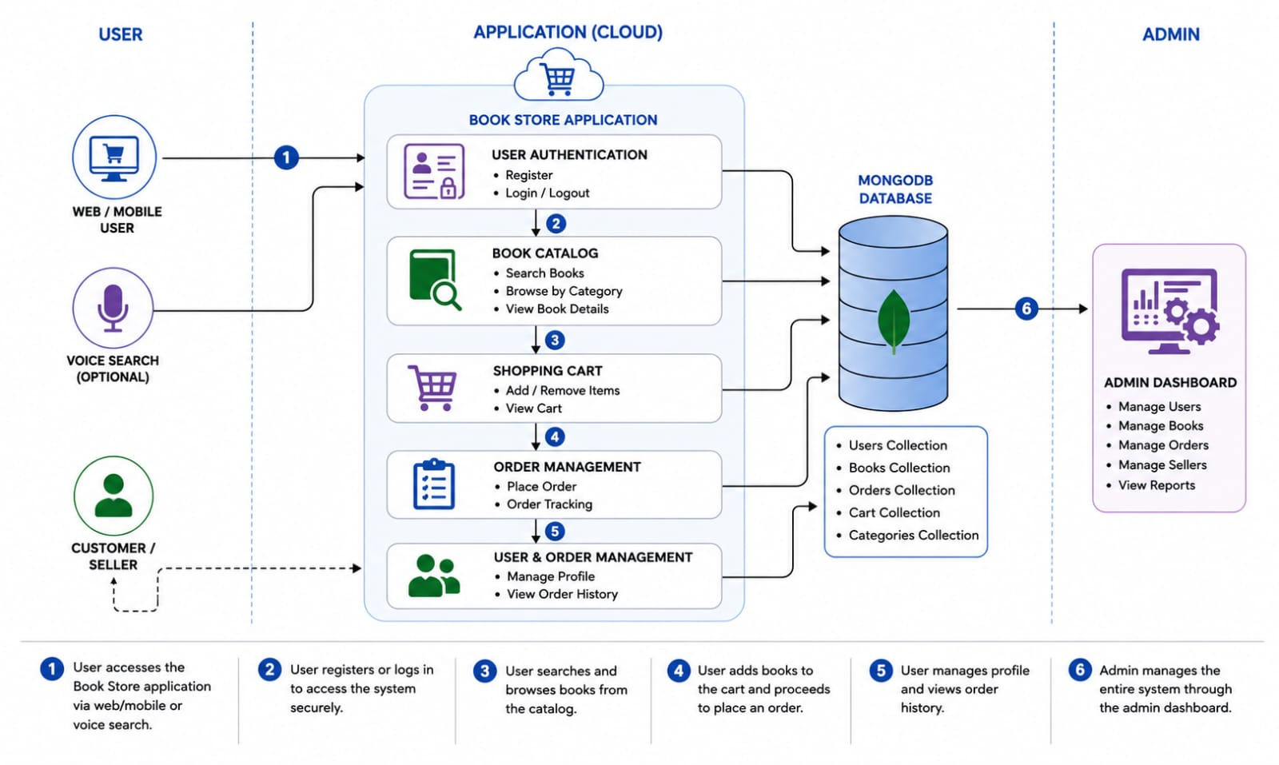
Reference: https://www.mongodb.com/resources/languages/mern-stack-tutorial
Guidelines:
Include all application modules (Registration, Login, Search, Cart, Orders, Admin).
Separate local and cloud components clearly.
Show external APIs (Payment Gateway, Email Service).
Include MongoDB Atlas as the data storage.

Table-1 : Components & Technologies:
S.No | Component | Description | Technology
 | User Interface | Customer, Seller & Admin web application | HTML5, CSS3, JavaScript, React.js
 | Application Logic-1 | User Authentication & Authorization | Node.js, Express.js, JWT
 | Application Logic-2 | Book Management (Add, Update, Delete, Search) | Node.js, Express.js
 | Application Logic-3 | Shopping Cart & Order Management | Node.js, Express.js
 | Database | Store users, books, orders, and cart details | Store users, books, orders, and cart details
 | Cloud Database | Cloud-hosted MongoDB database | MongoDB Atlas
 | File Storage | Store book cover images | Local File System / Cloudinary
 | External API-1 | Online payment processing | Stripe API / Razorpay API
 | External API-2 | Email notifications for registration and orders | Nodemailer (SMTP)
 | Machine Learning Model | Book recommendation (Future Enhancement) | Recommendation Algorithm
 | Infrastructure (Server / Cloud) | Application deployment | Local Server / Render / Vercel / MongoDB Atlas

Table-2: Application Characteristics:
S.No | Characteristics | Description | Technology
 | Open-Source Frameworks | Frameworks used for frontend and backend | React.js, Node.js, Express.js, MongoDB
 | Security Implementations | Secure login, password encryption, JWT authentication | bcrypt, JWT, HTTPS
 | Scalable Architecture | Three-tier architecture separating frontend, backend, and database | MERN Stack (3-Tier Architecture)
 | Availability | Cloud database with continuous availability | MongoDB Atlas, Render/Vercel
 | Performance | Fast API responses, optimized database queries,  responsive UI | Express.js, MongoDB Indexing, React.js

References:
https://c4model.com/
https://expressjs.com/
https://nodejs.org/docs/latest/api/

